***Principle Engineer Candidate***: Brett Shelley, [bshelley585@gmail.com](mailto:bshelley585@gmail.com), Phone: (717) 585 3726

**Subject**: Coding Assignment

**Reference**: See Library PostMan Collection in Source Code. Import it into your PostMan environment if you so choose.

**Comments**: When directed to create an API for a library that lists books and enables CRUD operations, I thought, why not build out a Spring Boot application that contains RESTful API web service calls. So, here it is – done quickly and at night:

**Technical Details:**

This document contains examples of create, read, update and delete (CRUD) operations for a RESTful web services API. The following pages show POSTMAN screenshots of the example output. The library is a bit small - just 5 or 6 books. Further, the library has no persistence layer. Still- as long as the server is running - you can add books, update books, delete books, and list the books in the library.

1. To just run the jar quickly:

***java -jar lib.zip --server.port=8081***

(You can’t eat cake for breakfast but you can rename a jar file as a zip file. 😉 )

1. To build the project:

***gradle clean build***

1. To run the server if you have latest Gradle (version 6.7ish):

***gradlew bootRun***

1. To run the jar built in the build/libs directory:

***java -jar ./build/libs/library-service-0.0.1-SNAPSHOT.jar --server.port=8081***

1. Import the PostMan collection to test out the service

This file is in root project directory with the name library.postman_collection.json.

The following pages show curl requests for the simply invoked web services. These pages also show Postman screenshots showing how the simple program worked.

**List Books:**

curl http://localhost:8081/listBookss

Example Postman GET request:

Figure 1: List Books Screenshot

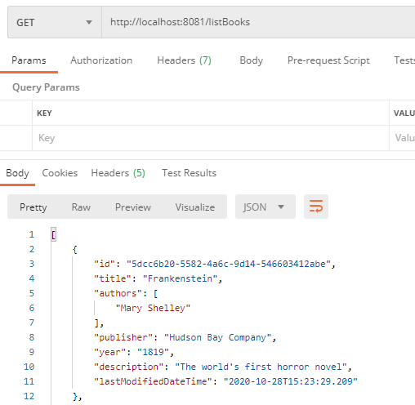

**Create Book**:

Example PostMan POST request:

Figure 2: Create Book PostMan Screenshot

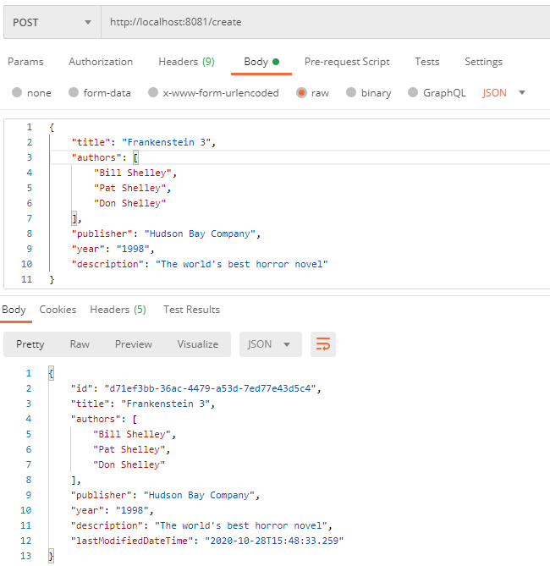

**Update Book:**

Example PostMan PUT request:

Figure 3: Update Book PostMan Screenshot

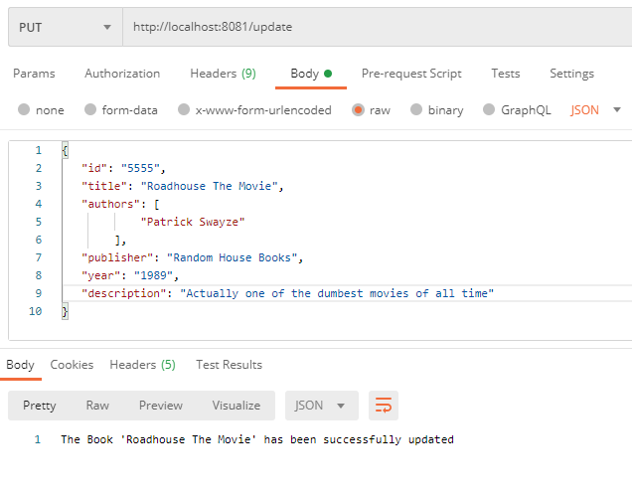

**Delete Book**:

Example Postman Delete request

curl -X DELETE http://localhost:8081/delete/5555

Figure 4: Delete Book Postman Screenshot

